

Capstone Project Report
Report 2 – Project Management Plan

– HoChiMinh, January 2025 –

Contents
I. Record of Changes 2
II. Project Management Plan 3
1. Overview 3
1.1 Table 3
1.2 Project Objectives 10
1.3 Project Risks 10
2. Management Approach 11
2.1 Project Process 11
2.2 Quality Management 11
2.3 Training Plan 12
3. Project Deliverables 12
4. Responsibility Assignments 13
5. Project Communications 14
6. Configuration Management 15
6.1 Document Management 15
6.2 Source Code Management 15
6.3 Tools & Infrastructures 15

I. Record of Changes
Date | A*  M, D | In charge | Change Description
17/01/2025 | A* | Luan
20/01/2025 | A | Luan
21/01/2025 | A | Luan | Table of Contents
*A - Added M - Modified D - Deleted

II. Project Management Plan

1. Overview

1.1 Table
WBS Item | Functionature | Function | Complexity | Est. Effort (man-days)
1 | Specification |  |  | 37
1.1 |  | Stakeholder register | Simple | 3
1.2 |  | Requirement definition | Medium | 5
1.3 |  | Project planning | Medium | 5
1.4 |  | Deliver report 1 - Project Introduction | Medium | 4
1.5 |  | Deliver report 2 - Project Management Plan | Medium | 4
1.6 |  | Deliver report 3 - System Requirement Specification | Complex | 8
1.7 |  | Deliver report 4 - Software Design Document | Complex | 8
2 | Design |  |  | 23
2.1 |  | Development tools selection | Simple | 2
2.2 |  | Database design | Complex | 8
2.3 |  | Design UI prototypes | Medium | 5
2.4 |  | Software design document | Complex | 8
3 | Web application for Admin |  |  | 62
3.1 | Function-01 | Login | Simple | 2
3.2 | Function-02 | Logout | Simple | 1
3.3 | Function-03 | View personal profile | Medium | 3
3.4 | Function-04 | Update personal profile | Medium | 3
3.5 | Function-05 | Change password | Medium | 2
3.6 | Function-06 | View user (manager) | Simple | 1
3.7 | Function-07 | Add user (manager) | Simple | 1
3.8 | Function-08 | Update user | Simple | 1
3.9 | Function-09 | Delete user | Simple | 1
3.10 | Function-10 | View category | Simple | 1
3.11 | Function-11 | Edit category | Simple | 1
3.12 | Function-12 | View vehicle | Medium | 3
3.13 | Function-13 | Edit vehicle | Medium | 3
3.14 | Function-14 | View scenic route | Medium | 3
3.15 | Function-15 | Add scenic route | Complex | 6
3.16 | Function-16 | Edit scenic route | Complex | 6
3.17 | Function-17 | View bus stop | Medium | 3
3.18 | Function-18 | Add bus stop | Complex | 3
3.19 | Function-19 | Delete bus stop | Medium | 4
3.20 | Function-20 | Edit bus stop | Medium | 3
3.21 | Function-21 | View services config | Simple | 1
3.22 | Function-22 | Update services config | Simple | 1
3.23 | Function-23 | View price of vehicles | Simple | 1
3.24 | Function-24 | Edit price of vehicles | Medium | 3
3.25 | Function-25 | Calculate virtual currency | Simple | 1
3.26 | Function-26 | View booking history | Medium | 3
3.27 | Function-27 | View money | Medium | 3
4 | Web application for Manager |  |  | 22
4.1 | Function-28 | Login | Simple | 2
4.2 | Function-29 | Logout | Simple | 1
4.3 | Function-30 | View driver | Medium | 3
4.4 | Function-31 | Add driver | Medium | 2
4.5 | Function-32 | View customer | Simple | 1
4.6 | Function-33 | View driver schedule | Simple | 3
4.7 | Function-34 | Edit driver schedule | Complex | 10
5 | Mobile application for Driver |  |  | 53
5.1 | Function-35 | Login | Simple | 0.5
5.2 | Function-36 | Logout | Simple | 0.5
5.3 | Function-37 | View booking | Medium | 5
5.4 | Function-38 | Accept booking | Medium | 5
5.5 | Function-39 | View route (map) | Complex | 10
5.6 | Function-40 | View personal schedule | Medium | 3
5.7 | Function-41 | Check-in | Medium | 3
5.8 | Function-42 | Check-out | Medium | 3
5.9 | Function-43 | View trip | Complex | 10
5.10 | Function-44 | Chat with customer | Medium | 5
5.11 | Function-45 | View history of booking | Medium | 6
5.12 | Function-46 | View notification (real-time) | Medium | 6
5.13 | Function-47 | View profile | Medium | 6
6 | Web application for Customer |  |  | 78
6.1 | Function-48 | Login by OTP | Simple | 2
6.2 | Function-49 | Logout | Simple | 1
6.3 | Function-50 | Booking by hour | Complex | 8
6.4 | Function-51 | Booking by route | Complex | 8
6.5 | Function-52 | Booking by destination | Complex | 8
6.6 | Function-53 | Share on-demand bridge | Complex | 10
6.7 | Function-54 | View bus route map | Medium | 5
6.8 | Function-55 | Buy bus ticket | Medium | 5
6.9 | Function-56 | Real-time ride tracking | Complex | 10
6.10 | Function-57 | Rating | Medium | 3
6.11 | Function-58 | Feedback | Medium | 2
6.12 | Function-59 | View profile | Medium | 3
6.13 | Function-60 | Update profile | Medium | 2
6.14 | Function-61 | Chat with driver | Medium | 5
6.15 | Function-62 | View detail of trip | Simple | 1
6.16 | Function-63 | View booking history | Medium | 2
6.17 | Function-64 | Payment | Medium | 3
7 | System |  |  | 17
7.1 | Function-65 | Refund | Medium | 2
7.2 | Function-66 | Real-time tracking | Complex | 8
7.3 | Function-67 | Real-time notification | Medium | 3
7.4 | Function-68 | Real-time chat | Medium | 4
Testing
WBS Item | Testing Stage | Complexity | Est. Effort (man-days)
T1 | Unit testing | Medium | 6
T2 | Integration testing | Medium | 6
T3 | System testing | Medium | 6
Closing
WBS Item | Activity | Complexity | Est. Effort (man-days)
C1 | User guide | Medium | 5
C2 | Final report | Medium | 5
Total Estimated Effort (man-days): 320

1.2 Project Objectives

# | Testing Stag | Testing  Coverage | No. of Defects | % of Defect | Notes
1 | Reviewing | 50% | 12 | 20
2 | Unit Test | 60% | 12 | 10
3 | Integration Test | 50% | 12 | 30
4 | System Test | 50% | 12 | 30
5 | Acceptance Test | 60% | 12 | 10

1.3 Project Risks
# | Risk Description | Impact | Possibility | Response Plans
1 | Team members drop out | Critical | Medium | Reduce or change scope  Find new member
2 | VPS stop running | Critical | High
3 | Third party API not working | Critical | Low

2. Management Approach

2.1 Project Process
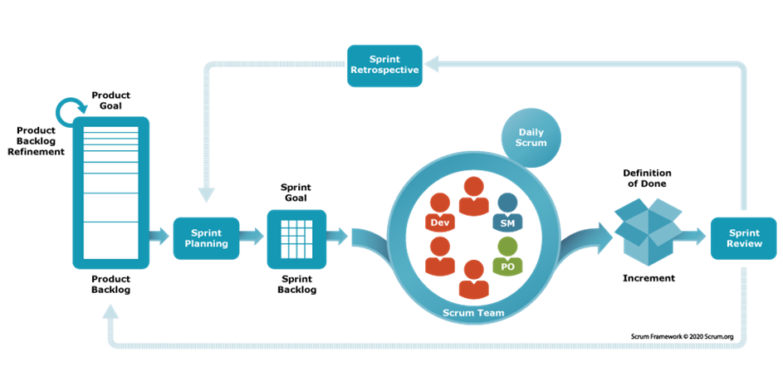
Source: https://www.scrum.org/learning-series/what-is-scrum/

2.2 Quality Management
Vin Shuttle is developed and managed based on the Scrum model. The reason we decided to use this model is because:
- Enhanced Collaboration and Communication
- Accelerated Project Delivery with Iterative Development
- Flexibility and Adaptability to Change
- Continuous Improvement through Regular Reflection
In this project, to improve the project quality, we use the following approach:
API Convention
- Name the API Route that maps to the entity in the system.
- Each API response must return the following general information:
  - Status Code: 200, 400, 403, 404, etc.
  - ErrorCode: 201, 401, etc.
  - Success: True, False
  - Status Text: Not Found, Success, etc.
  - Total: Number of data items returned
  - Data: An array that contains all data items
Coding Convention
- Set meaningful names for variables.
- Add comments to the code if necessary to avoid confusion.
- Use Pascal casing for naming Enums, Classes, Interfaces, and Attributes.
- Use Camel casing for naming variables.
Unit Testing: Each member has the responsibility to write a unit test to ensure a function/method works appropriately.
Integration Testing: After finishing coding one module/screen, both members working on the client-side and server-side need to execute integration testing to ensure the module/screen can work smoothly from the client-side to server-side.
System Testing: After finishing coding for the whole system, all team members need to re-execute all test cases and free tests to ensure the system is stable.

2.3 Training Plan
Training Area | Participants | When, Duration | Waiver Criteria
NextJS | All member | 10days | Mandatory
NestJS | All member | 10days | Mandatory
React Native | All member | 7days | Mandatory
Git/Github | All member | 1day | Mandatory

3. Project Deliverables

No | Delivery | Due day | Note
1 | Project plan | 11/02/2025 | Make project goal plan
2 | Report 1 | 11/02/2025 | Project introduction
3 | Report 2 | 11/02/2025 | Project management plan
4 | Report 3 | 11/03/2025 | Software requirement specification
5 | Report 4 | 11/03/2025 | Software design document
6 | Report 5 | 15/04/2025 | Test case document, test documentation
7 | Report 6 | 15/04/2025 | Software user guides
8 | Report 7 | 15/04/2025 | Appendix
9 | Code package 1 |  | Features for landing page web interface
10 | Code package 2 |  | Features for customer web application
11 | Code package 3 |  | Features for admin web application
12 | Code package 4 |  | Features for mobile application
13 | Code package 5 |  | Final code package and document

4. Responsibility Assignments
D~Do; R~Review; S~Support; I~Informed; O- Omitted

Responsibility | Luan | Nhat | Quang | Khanh | Mentor
Collect and specify user requirements | S | D | D | S | R
Analyse project requirements | S | D | D | S | R
Find solutions and fix problems that arise | S | D | D | S | R
Specify system features | I | D | D | S | R
Business analysis team guide | D | I | D | S | R
Manage members' tasks | S | S | D | I | R
Support members to solve problems | D | S | D | I | R
Design Interface of web, app | D | I | S | D | R
Database design | S | D | D | I | R
Implement interactions for the user interface | D | S | I | D | R
Create Test view point, test plan, test cases | S | I | S | D | R
Execute test, manage bugs | S | S | I | D | R
Write test report | S | S | I | D | R

5. Project Communications
Communication Item | Who/Target | Purpose | When, Frequency | Type, Tool, Method(s)
Daily meeting | Team members | Review project progress  Discuss and solve problems  Discuss about project’s  business | Every workday | Discord, Messenger
Meeting supervisors | Supervisors and team members | Review project progress  Review project document,  core flows  Technical support  Give advice and direction | Every weekends | Google meet, Zalo, directly at FPTU

6. Configuration Management

6.1 Document Management
Because of the real-time data synchronization, we use Google Docs to manage documents. Google Drive allows team members to conveniently collaborate in real- time. We create documents on Google Docs based on the document template, then divide the document writing work for members based on their predefined responsibilities. Each member can see the results of the other members' work instantly.

6.2 Source Code Management
Creating git for frontend, backend, mobile. In one source project, we created a dev branch or branch based on members to build features. After that, we made a pull request from the current branch to the master or main branch that is deployed into the server. During pull request, merged codes will be sent to the server for passing pipelines and accept merge thereafter.

6.3 Tools & Infrastructures
Category | Tools / Infrastructure
Programming language | Typescript, Javascript
Technology | NextJS (FrontEnd), React Native (Mobile), NestJS(BackEnd)
Database | MongoDB, Redis
IDEs/Editors | Visual Studio Code, MongoDBCompass
Diagramming | DrawIO, Visual paradigm/Visual paradigm online
Documentation | Ms Office, Google Docs/Sheets/Slides, Canvas
Version Control | Github (Source Codes), Google Drive (Documents), Google Docs
Deployment server | Vercel (front-end), Private VPS (Back-end)
Project management | Discord (task), Message (communicate)

